VENANGO TECHNOLOGY CENTER
JOINT COMMITTEE
1 Vo-Tech Drive
Oil City, Pennsylvania 16301

MINUTES

May 3, 2021

The regular meeting of the Venango Technology Center Joint Committee was held this evening in the Conference Room of the Venango Technology Center, 1 Vo-Tech Drive, Oil City, PA 16301. Mr. Come called the meeting to order at seven o’clock (7:00) p.m.

Mr. Come asked the members to pause for a moment of silence.

Mr. Come asked the members to stand for the pledge of allegiance.

Roll Call: Present: Todd Carson, Robert Blauser, Andy Boland (zoom), Shari Neely, Mark Marterella,
Jeff Thomas (zoom), Don Judy, James Come

Absent: Troy Johnston, James Disque

Also Present: Mr. Mario Fontanazza

Mr. Come stated the Joint Committee members had received copies of the Minutes of the April 5, 2021 meeting in the mail. He asked if there were any additions, corrections or deletions.

Mr. Marterella, seconded by Mr. Carson, moved to approve the Minutes of the April 5, 2021 meeting as submitted.

Roll Call: Ayes: Todd Carson, Robert Blauser, Andy Boland, Shari Neely, Mark Marterella,
Jeff Thomas, Don Judy, James Come

Nayes: None, motion carried.

The Treasurer and Secretary’s Report as of 5/3/21 were submitted for information.

Mr. Blauser, seconded by Mr. Carson, moved to accept the Treasurer and Secretary’s Report as of 5/3/21 as submitted.

The motion was unanimously approved.

A list of bills from 4/6/21 – 5/3/21 in the amount of $461,210.21 was presented for approval.

Mr. Marterella, seconded by Mr. Carson, moved to approve the list of bills as presented.

Roll Call: Ayes: Todd Carson, Robert Blauser, Andy Boland, Shari Neely, Mark Marterella,
Jeff Thomas, Don Judy, James Come

Nayes: None, motion carried.

Under Communications, Mr. Fontanazza discussed the Professional Advisory Committee. He also discussed the Calendar of Events for the month of March and the Monthly Enrollment Report as of 5/3/21 were submitted.

Mr. Come requested approval of the action items as presented. Item 8. a) ii.- ix. in one motion.

Mr. Carson, seconded by Mr. Marterella, moved to approve action items ii.- ix. as follows:

- Approve additions to Occupational Advisory Committees.
- Approve equipment for disposal.
- Approve the purchase of a trailer for building a tiny home at a cost not to exceed $10,000.00.
- Approve contract with Curvco Steel Structures for $18,892.00.
- Approve Non-bargaining salary schedule for 2021-2022.
- Approve summer per diem requests.
- Approve Franklin Insurance as the Tech Center insurance carrier.
- Approve Board policy changes as presented.

Roll Call: Ayes: Todd Carson, Robert Blauser, Andy Boland, Shari Neely, Mark Marterella,
Jeff Thomas, Don Judy, James Come

Nayes: None, motion carried.

Mr. Come requested nominations for Treasurer of Board. (Term runs from 7/1/21 – 6/30/22)

Mr. Carson, seconded by Mrs. Neely moved to nominate Mr. Marterella as Board Treasurer.

Roll Call: Ayes: Todd Carson, Robert Blauser, Andy Boland, Shari Neely, Mark Marterella,
Jeff Thomas, Don Judy, James Come

Nayes: None, motion carried.

Mr. Fontanazza reviewed his Issues/Activities for April 2021.

Mr. Come asked if there was any old business.

None was noted.

Mr. Come asked if there was any new business.

None was noted.

Upon motion by Mr. Marterella, seconded by Mr. Carson, the meeting adjourned at twenty minutes past seven (7:20) p.m.

Recorded by
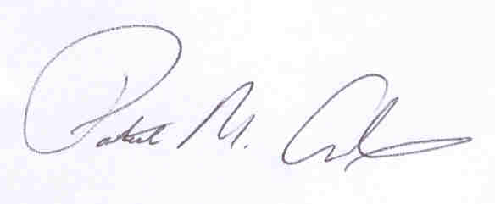
Patrick M. Adams
Secretary, Joint Committee

